- INTRODUCTION
  - BACKGROUND OF THE STUDY
As the society progresses and as technology develops, cars have become a human necessity. Presently, the automotive industry has grown to the extent that each family would own their own car. In addition, with the help from low-interest car loans, the number of cars for private use has increased drastically over the years. This prompted several commercial establishments to provide larger parking spaces which will accommodate the needs of the costumer. As a result, the management would have to provide more efficient quality service in their parking system.
  - STATEMENT OF THE PROBLEM
Present large scale parking systems have become harder to manage, due to the accuracy, efficiency, and accessibility of the information. One error that usually occurs is human error. The employees at the entrance and exit of the parking may have the tendency to record the information incorrectly. This will lead to inaccurate information for the database. Furthermore, the database would be inefficient because of these inaccuracies. This could be solved through the use of cameras that could capture the image and store it. However, it is not advisable to use images since they consume too much memory space leading to more expense.
Another factor that would affect car park expansions is the storage of information. Storage of a large amount of tickets containing the information about cars entering and leaving the premises is hard to manage. As a result, only the most recent information are filed and the logs of the parking premises. Aside from that, occurrence of natural disasters such as calamities, fires, or earthquakes may cause these files to be damaged or destroyed.
On the other hand, accessibility of information should still be considered. Large amount of tickets piled up in one location would cause difficulty in searching for specific information. This would be unfortunate for people wanting to gain information about the cars entering and leaving the car park premises because they have to go through so much difficulty in looking for the information needed. In addition, unauthorized personnel may just break inside the office and go through the files without any restrictions.
  - OBJECTIVES
    - GENERAL OBJECTIVES
      - To develop a car park system with automated log in and log out process.
    - SPECIFIC OBJECTIVES
      - To utilize a camera that will capture the car plate.
      - To develop the software that will convert the car plate image into text.
      - To develop the database system that will generate the time logs of cars entering the car park for computation of parking fee.
      - To be able to print a ticket that includes a barcode that can be used to access the database.
      - To use an LED display that will show the number of slots available per area.
      - To obtain a 70% accuracy for the conversion process and 90% for the overall system.
      - To develop a sensor system that will check the availability of parking slots.
  - SCOPE AND DELIMITATION
The scope of this study will only include the standard car plates that use a font color of green and have a format of three letters and three numbers respectively. Plates that use a different font color will not be included in the study. In addition, plates that are covered in glass or plates that are glossy are also not included in the system due to the reflection that they may incur.
The study will also not include specially-made plates such as government plates and euro plates into the system. Furthermore, the study will not include motorcycle plates. Vehicles with specially-made plates that wish to enter the parking system would have to manually enter their plate number through the use of a keyboard.
This study will also be limited to cars that have their plates located on the bumper or on the lower middle side of the car’s front part because the camera of the system will be on a fixed position. Plates that are not located on the indicated position would result to the system encountering an error.
In cases wherein the system fails to recognize the plate number, the driver would be asked to input the plate number manually using the keyboard. The keyboard would serve as an alternative solution and compensation for the limitation of the system.
The study will consider testing parameters for checking the efficiency of the system. The parameters included in our study are: (1) number of plates, (2) camera angle at the entrance and exit stations of the parking lot, (3) car’s position, (4) camera’s distance from the car, (5) lighting condition of the environment, and (6) response time of the system.
The study has delimited the use of the specially made plates, government plates, dirty plates and wet plates, however, the study will use these plates for the purpose of testing the system and check how the system will react from it.
  - SIGNIFICANCE OF THE STUDY
The automation of the log-in and log-out process of the car park system makes the whole process more convenient and organized for both the management and the consumers. Through automation, the system would no longer need manpower in handing out the parking tickets to the customers. In addition, the use of digital image processing could help lessen the errors produced by man. Automating the log-out process, in the other hand, enhances the security and convenience for the customers because no car would be able to exit the premises without the ticket issued at the entrance. Owners can be assured that the system could prevent car theft. Furthermore, the database of the system would also help in enhancing the security because it tracks the entry and exit time of the car along with other information about the car such as its plate number. This way, the management would have an easier time to access and manage the parking system effectively.
The LED display in the parking system would also help in determining the number of slots available. Knowing the available slots left would help the customers to decide whether they would park their car or not. Moreover, sensors installed in the system would make it more convenient for the customers to find a parking space. Through this process, the customers would consume less time finding a parking space for their car.
  - DETAILED PROJECT DESCRIPTION
Figure 1-1 shows the detailed flow of how the parking system should work. First, when the car enters the parking premises, the camera will capture an image of the car plate. The image will then be processed and will be converted into a form suitable for storage. A display monitor at the check-in station will display the registered car plate obtained during conversion. If the conversion is correct, the user will now be issued a ticket with a unique barcode that will be used to retrieve necessary information in checking out. However, if the conversion is incorrect, the user may manually input the information through the use of a keyboard that is placed at the check in station.
The number of available slots displayed in the LED display will decrease by one. Through the use of sensors installed in each parking slot, the driver will find it easier to find an available parking slot. Once an available slot is occupied, the sensor will indicate that the parking slot is already unavailable. On the other hand, once a car leaves the parking slot, the sensor will indicate that the parking slot is available.
Upon exiting, a camera will again be utilized to check the car plate of the car leaving the premises which will then be converted into text. Employee will use a bar code reader to retrieve the data necessary, and then checks if the retrieve car plate number and the converted plate number are same. If it does, the system will compute for the parking fee and check the car out. The number of available slots displayed in the LED display will increase by one. If the car plate does not match, the employee will alert the security and security procedures will be done.
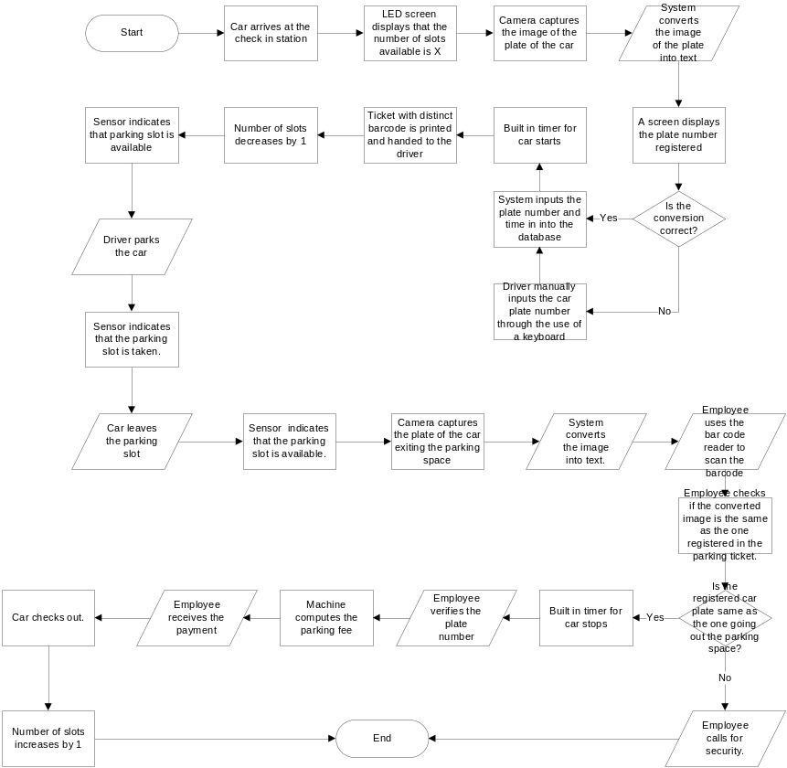
Figure 1-1. Flowchart of the whole parking process
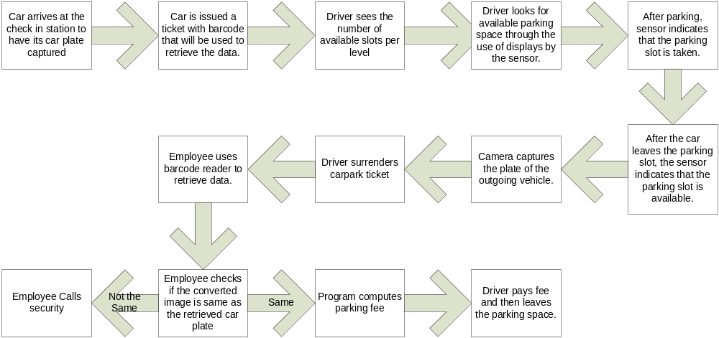
Figure 1-2. Simplified Flowchart of the whole parking process
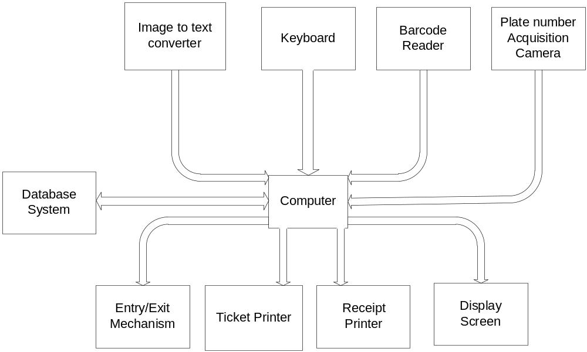
Figure 1-3. Showing the Different Parts of the Project
Figure 1-3 shows that all the parts of the system are controlled by the computer. Each component uses the computer to communicate with other components of the system. The database is connected bidirectional since the database system is required to communicate and exchange information. The image to text converter will be used to convert the image coming from the camera to process it and convert to text. The barcode reader will be used to access data stored in the database. The printer generates the corresponding barcode of given information. The entry and exit mechanism will be used for blocking the entrance/exit when the process in ongoing and the parking space GUI is to check the parking lots if it is available or occupied.
The technique to be used, Image Matrix Manipulation works in the following manner: First, the image captured by the camera filters the images into two colors: black and white. Then, the image is converted into a matrix, and from there, the database of stored matrices will be checked for the closest match. The closest match will be provided by the software as an output.
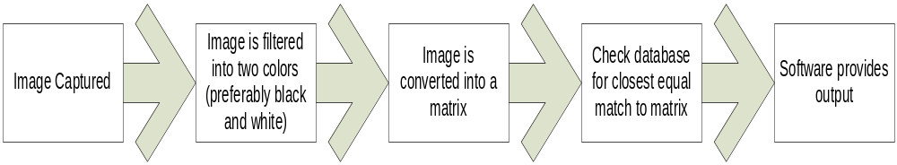
Figure 1-4. Digital Imaging Process
  - METHODOLOGY
The researchers will rent an open lot located in Metro Manila where the system would be tested and implemented. For testing the system, 10 cars would be utilized for the parking space. Five parking spaces would be installed with sensors to check for the number of slots available in the parking area.
The researchers would also track the number of times the system successfully converted the characters of the plates. The performance of the system can be evaluated by counting the number of logs that were recorded by the system. This way, the researchers would be able to easily identify how accurate the system is. In addition, this would also help in making the necessary adjustments to create a more accurate system. Furthermore, knowing the accuracy would help the researchers determine the factors that affect the digital image processing of the system.
The group will conduct a survey on various people that would determine their current preference on present parking lot systems. Surveys regarding the system that the researchers proposed would also be conducted. This would determine whether the proposed system would benefit the customers more than the current system.
The group would also track the time it takes for the system to complete the log-in process. The time obtained would then be compared to the time it takes to complete the log-in process in current parking lot systems. Since the proposed system is to be automated, the time obtained from the proposed system should be less than the time obtained from the current parking lot systems.

  - GANTT CHART
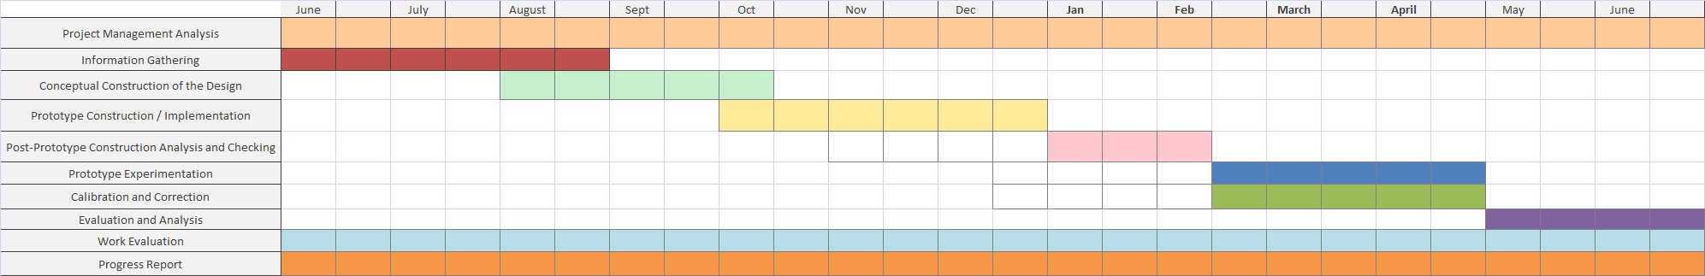
  - BUDGET AND ESTIMATION OF COST
Parts Price (in PHP)
Bar Code Scanner 3,000.00
Bar Code Printer 4,000.00
Computer 20,000.00
LCD Screen 10,000.00
Camera 3,000.00
Keyboard 200.00
Sensors 10,000.00
PCB 500.00
Electric Wire 100.00
Electric Components 500.00
Estimated Total Cost 51,300.00

